SHEET CALCULATION BUTTON FOR PICKING STOCK SHEETS or ROLLS

The Job file and the Estimate program have a button called Sht Calc which allows selecting stock rolls and sheets. ASI recommends using the SHT CALC button in the job file to select a stocked sheet or a stocked roll size to issue to the production floor. The job example below is for a multiple part / form job. Please note, the sheet calculation button must be pressed for each form.

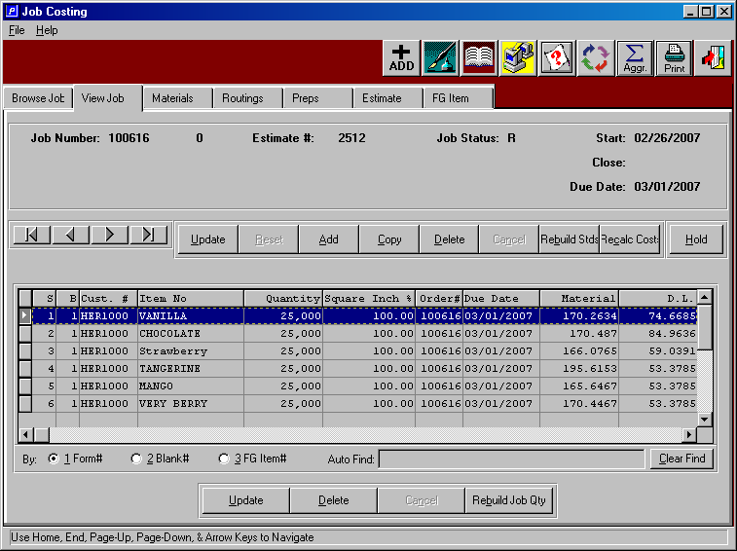

The SHT CALC button can be found in the job cost file at the bottom of the Material folder. Most often, the estimate is calculated with a generic estimated material such as 200C or SBS18 which has no defined sheet size in the raw materials file. The estimate program calculates the sheet size based on the style formulas and also adds trim waste from the machine file.

Highlight the board material that you wish to replace with a stocked sheet or roll size. The system will only show material larger than the width and length for the job.

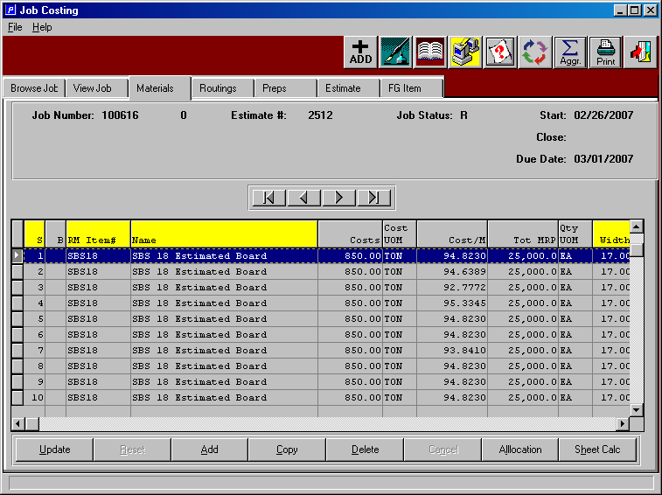

Sheet Calculation button displays popup window that allows you to select a machine and a board grade. Please note, you can press F1 on either field to select a machine or a material.

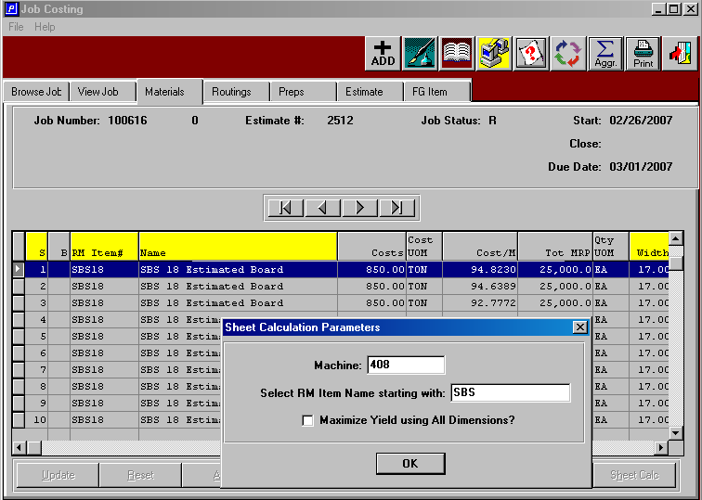

Once a board grade is selected, the available board material will display that is available. The screen below shows all the material that will run on the machine listed above and is large enough for the sheet size defined for the job. Please note, the job requires 25,000 sheets, however our sheet which is the best fit has an insufficient number of sheets for the entire job. No problem, we can pick any tag number and then simply run the sheet calculation program again.

Please note, the N-K-1 ShtCalc control parameter dictates the default select as either show all items regardless of quantities, show only on hand greater than required by job or show only board with quantity available greater than zero. While a board may be on hand, pallets or roll tags may be committed to other jobs, hence quantity available is a more accurate benchmark for issuing material to a job.

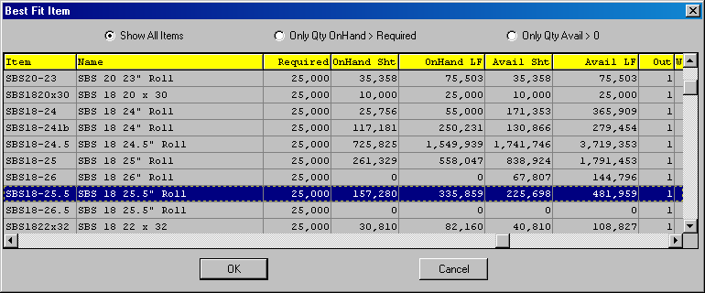

When the board material selected does not have enough on hand material, this message will appear just as a warning so that you may want to select another item that has enough on hand quantity to run the entire job. If you want to use the remaining balance of this time, simply click yes and the item will be added to the jobs material folder.

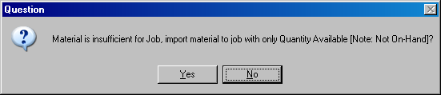

Once we select the board material, we can also issue tag numbers to the job.
The N-K-1 RMISSUE value dictates issues during the sheet calculation.

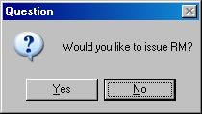

Once the roll tags or pallets of sheets are selected, the system prompts to confirm the creation of issues to the job.

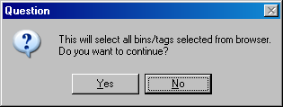

Once the warehouse location, bin location and pallet / roll tag is selected, the system verifies the job quantity required against the bin selected. When the material on hand for the specific tag exceeds the quantity required for the job, the system needs your help.
Answer YES to issue the entire quantity in the tag. This may be good when the on hand quantity of the tag is just slightly over the quantity required for the job.
Answer NO to issue only the quantity required for the job.

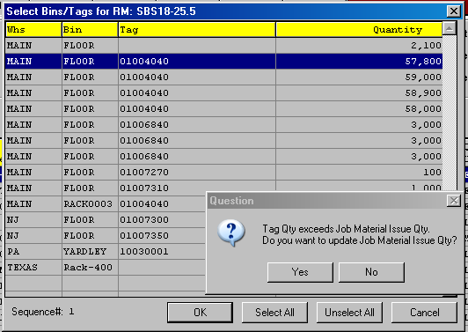

Raw Material issues are created via the sheet calculation program and may be modified as needed via the issue program in the raw materials warehouse transactions menu.

